# Technical Design Document: Programming Exercise 7

# Name: Lucas Korzeniewski
# Date: June 28, 2026
# Program Description: This program allows the user to enter a paragraph of text. The program uses a regular expression to separate the paragraph into individual sentences, including sentences that begin with numbers. It displays each sentence on its own line and then displays the total number of sentences entered.

## Function: get_paragraph()
Prompts the user to enter a paragraph and returns the paragraph.
Parameters:
None
Variables:
paragraph (string): Stores the paragraph entered by the user.
Logic:
- Prompt the user to enter a paragraph.
- Store the user's input in the paragraph variable.
- Return the paragraph.
Return:
paragraph (string): The paragraph entered by the user.
None

## Function: display_sentences(paragraph)
Finds each sentence in the paragraph, displays each sentence, and returns the total number of sentences.
Parameters:
paragraph (string): The paragraph entered by the user
Variables:
sentences (list): Stores all sentences found in the paragraph.
count (integer): Displays the sentence number during the loop.
sentence (string): Represents the current sentence being displayed.
Logic:
- Search the paragraph for sentences using a regular expression.
- Store the matching sentences in a list.
- Display a heading.
- Loop through the list of sentences.
- Display each sentence with its number.
- Return the total number of sentences found.
Return:
len(sentences) (integer): The total number of sentences.

## Function: display_sentence_count(sentence_count)
Displays the total number of sentences found in the paragraph.
Parameters:
sentence_count (integer): The number of sentences found.
Variables:
None
Logic:
1. Display the total number of sentences.
Return:
None

## Function: main()
Controls the overall flow of the program by calling the other functions.
Parameters:
None
Variables:
paragraph (string): Stores the paragraph entered by the user.
sentence_count (integer): Stores the total number of sentences.
Logic:
- Call the get_paragraph() function.
- Store the returned paragraph.
- Call the display_sentences() function.
- Store the returned sentence count.
- Call the display_sentence_count() function.
- End the program.
Return:
None

#Link to your repository: https://github.com/lucask333?tab=repositories
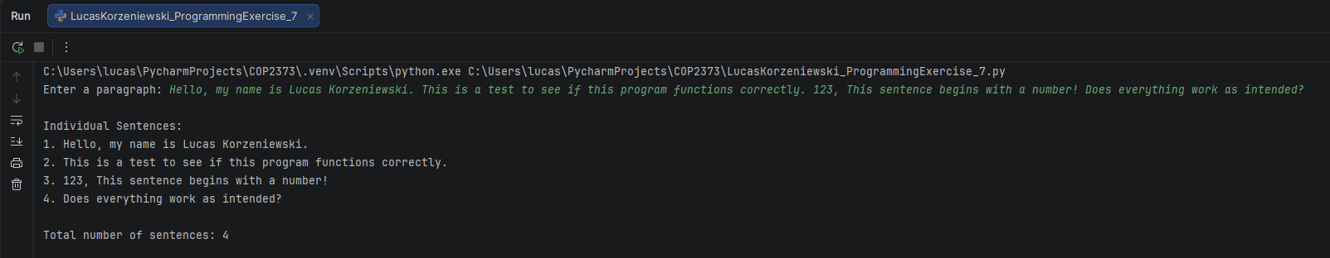
Output Screenshot: (make sure big enough so I can see)

